Morning,

Ten days to go, let’s look at the numbers.

Numbers
We are currently averaging 3.5k a day, with ten days to go we are on target for 110k.

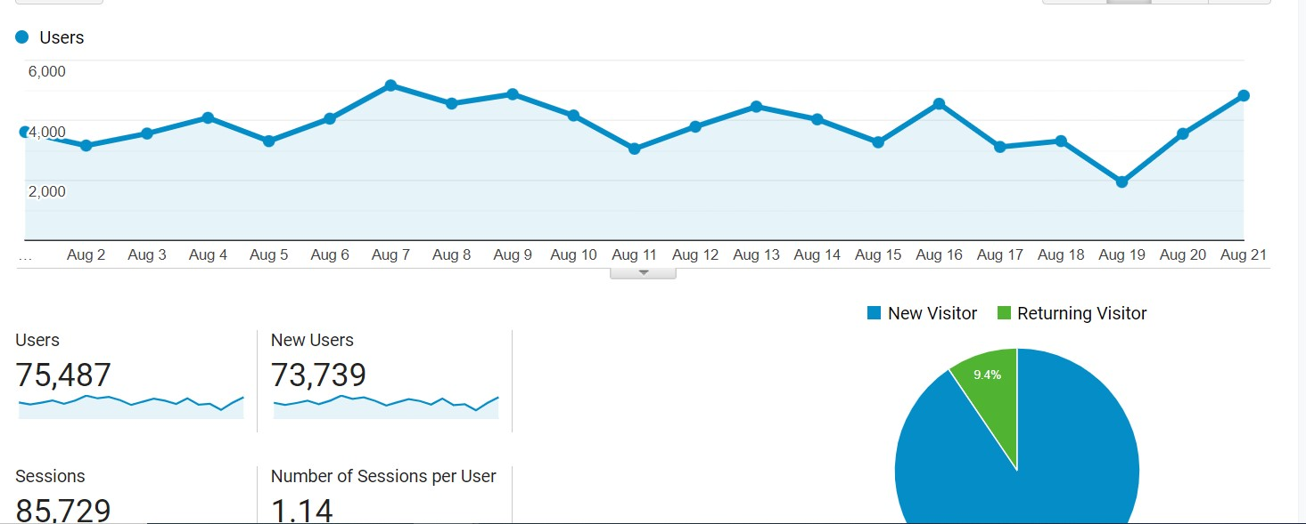

Week-on-week, we are down by 20% with social down (3,300 users) 17% and organic down 24% (2,300).

Content strat
Plenty of reason to see big gains this week with a number of updates coming out

Monday:

Monthly Clan Games

Tuesday:
Apex Legends 2.5

Wednesday:

Free Fire Weekly
Genshin Impact v3.0
Wild Rift f2p

Friday:

Wild Rift Samira, Sion, event

Saturday:

Free Fire Justin Bieber concert

On top of this, I (Daniel) will continue to put out long-tail COD Mobile guides with the launch of Season 8 expected on September 8 which should see a nice uptick in traffic.

Will also focus on Apex Legends Season 2.5 new season content and events.

We also want to increase the amount of Redeem Code Stories, as even ranking 2nd or 3rd with these will provide a solid base of traffic.

SEO Optimization

I have been working with the new SEO tool provided by Kim and will be working on a content strat for each of our core games with suggested topics and related keywords.

Lots of talk about the recent changes to Google Search, and its potential effect on gaming industry websites, we do need to take heed of this as it could have an effect on our ability to rank.

From the Guardian:

https://www.theguardian.com/technology/2022/aug/19/google-will-modify-search-algorithms-to-tackle-clickbait-seo

In one example, Sullivan says, a search about a recent movie can sometimes bring up articles that simply aggregate reviews from other sites; now, “you’ll see more results with unique, authentic information, so you’re more likely to read something you haven’t seen before”.

There are winners and losers from such changes, of course, and online publishers may fear that their content strategies will see them caught up in the net. In its advice for “content creators”, Google implies that some of the signals it will use to downgrade search results are whether or not a website has a primary purpose or focus, and whether there is “an existing or intended audience” that would find the content useful if they came directly to the page.

The “banhammer” will be wielded liberally. “Any content – not just unhelpful content – on sites determined to have relatively high amounts of unhelpful content overall is less likely to perform well in search, assuming there is other content elsewhere from the web that’s better to display,” Google says. “For this reason, removing unhelpful content could help the rankings of your other content.”

I believe the target of this is not websites like ours but we do have to take heed of this with the big takeaway being that we have to continually strive to do researched, original content that answers questions that searchers want the answers to. Not driven solely search traffic.

The only real way to do this is to get hands on time with each and every game we cover. In that sense, this change is a massive win for us.

Videos
After Paul greenlit the SPS highlights video format during the bi-weekly call, we can start rolling out these videos. It’s already been communicated with Leonardo that we’ll be transitioning to this format.

We’ll still be able to stick by our five videos per week output.

Social Media Updates
Facebook is consistenly growing. Organic reach is climbing again, however, post clicks is slightly down. Will discuss with Leopold during the bi-weekly SM meeting about paid marketing and how we could potentially use Facebook-specific captions to improve this.

